1. Concurrency problem: In parallel programs (one multi-threaded process), a common design methodology is to perform processing in sequential stages. All of the threads work independently during each stage, but they must synchronize at the end of each stage at a synchronization point called a barrier. If a thread reaches the barrier before all other threads have arrived, it waits. When all threads reach the barrier, they are notified and can begin execution on the next phase of the computation.
There are three complications to barriers. First, there is no master thread that controls the threads, waits for each of them to reach the barrier, and then tells them to re-start. Instead, the threads must monitor themselves and determine when they should wait or proceed. Second, for many dynamic programs, the number of threads that will be created during the lifetime of the parallel program is unknown in advance, since a thread can spawn another thread, which will start in the same program stage as the thread that created it. Third, a thread may end before the barrier. In all cases, all threads must synchronize at the barrier before the processing is allowed to proceed to the next phase.

a. Provide the pseudo-code for a monitor class called Barrier that enables this style of barrier synchronization. Your solution must support creation of a new thread (an additional thread that needs to synchronize), termination of a thread (one less thread that needs to synchronize), waiting when a thread reaches the barrier early, and releasing waiting threads when the last thread reaches the barrier. Implement your solution using monitors (e.g., wait(), signal(), and signalAll()). Your class must implement the following three methods: threadCreated(), threadEnd(), barrierReached().

b. In your barrierReached method, which conditional statement (i.e., if, or while) did you use and why?

2. You have just been hired by Mother Nature to help her out with the chemical reaction to form water, which she does not seem to be able to get right due to synchronization problems. The trick is to get two H atoms and one O atom all together at the same time. The atoms are threads. Each H atom invokes a procedure hReady when it is ready to react, and each O atom invokes a procedure oReady when it is ready. For this problem, you are to write the code for hReady and oReady. The procedures must delay until there are at least two H atoms and one O atom present, and then one of the threads must call the procedure makeWater (which just prints out a debug message that water was made). After the makeWater call, two instances of hReady and one instance of oReady should return. Your solution should avoid starvation and busy-waiting.
You may assume that the semaphore implementation enforces FIFO order for wakeups—the thread waiting longest in P() is always the next thread woken up by a call to V().

3. Some monkeys are trying to cross a ravine. A single rope traverses the ravine, and monkeys can cross hand-over-hand. Up to five monkeys can hang on the rope at any one time. If there are more than five, then the rope will break and they will all fall to their end. Also, if eastward moving monkeys encounter westward-moving monkeys, all will fall to their end. Assume that monkeys are processes.
(a) Write a monitor with two methods WaitUntilSafeToCross(Destionation dst) and DoneWithCrossing(Destination dst). Where Destination is an enumerator with value EAST=0 or WEST=1.

(b) Does your solution suffer from starvation? If so, briefly explain (e.g. give a sequence). Otherwise, simply state starvation-free. In either, cases state your assumptions, if any.

4. Suppose threads in a concurrent program share access to two different FIFO queues of data, QueueA and QueueB. There are two functions that threads use to move data items between the two queues:
- AtoB(): this function dequeues one item from QueueA and enqueues that item onto QueueB
- BtoA(): this function dequeues one item from QueueB and enqueues that item onto QueueA
Suppose that, initially, QueueA contains N data items, and QueueB is empty. On the next page, you will find skeleton implementations of AtoB() and AtoB(). Your job is to modify these functions by inserting semaphore operations to ensure that certain synchronization requirements are satisfied. These requirements are as follows:

1. dequeue() should never be run on an empty queue.
2. At most one thread at a time should be using each queue. For example, if one thread is running dequeue() on QueueA, no other thread should be running dequeue() or enqueue() on QueueA.
3. Items must be enqueued onto QueueB in the same order that they are dequeued from QueueA. Similarly, items must be enqueued onto QueueA in the same order that they are dequeued from QueueB.
4. Threads must never deadlock.

In addition, it must be possible, at least in some situations, for different threads to use different queues at the same time. In particular, a solution that uses a single semaphore to lock both queues is not acceptable.
Add semaphore operations (P and V) to the skeleton code given below so that these synchronization requirements will be satisfied. Do not use any synchronization primitives other than semaphores in your solution. Do not make any changes to the skeleton code other than inserting calls to semaphore operations.

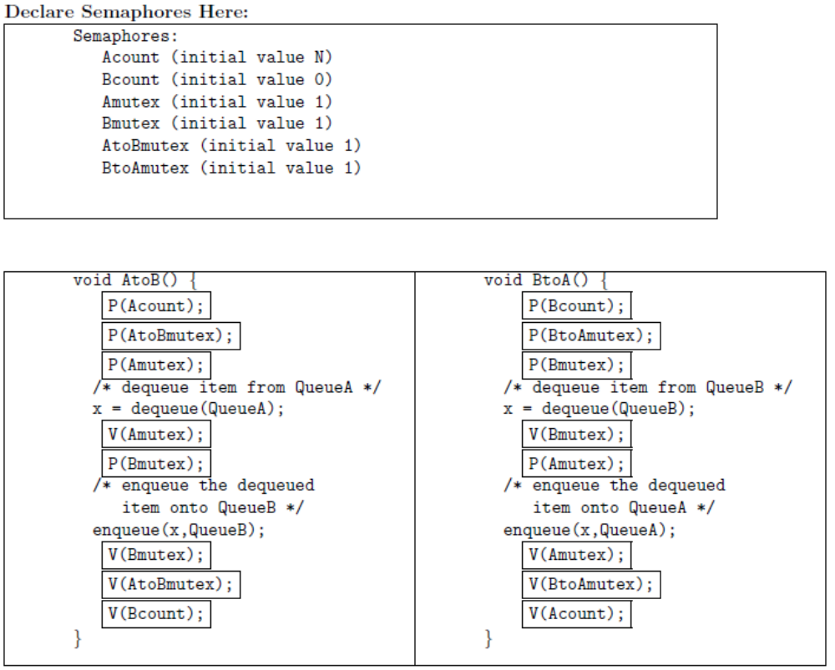

5. The following is a set of three interacting processes that can access two shared semaphores:
semaphore L = 3;
semaphore R = 0;

[Process 1] [Process 2] [Process 3]

L1:wait(L) L2:wait(R) L3:wait(R)
type("C") type("A") type("D")
signal(R) type("B") goto L3
goto L1 signal(R)
goto L2
Within each process the statements are executed sequentially, but statements from different processes can be interleaved in any order that's consistent with the constraints imposed by the semaphores. When answering the questions below assume that once execution begins, the processes will be allowed to run until all 3 processes are stuck in a wait() statement, at which point execution is halted.

- Assuming execution is eventually halted, how many D's are printed when this set of processes runs?

Exactly 3. Process 1 will execute its loop three times, incrementing "signal(R)" each time through the loop. (ie) Each time Process 1 executes the "wait(L)" statement, the value of semaphore L is decremented by 1. Since there are no "signal(L)" statements, the loop in Process 1 will execute only 3 times (ie, the initial value of L) and then stall the fourth time "wait(L)" is executed.
This will permit "wait(R)" to complete three times. For every "wait(R)" Process 2 executes, it also executes a "signal(R)" so there is no net change in the value of semaphore R caused by Process 2. Process 3 does decrement the value of semaphore R, typing out "D" each time it does so. So Process 3 will eventually loop as many times as Process 1.

- What is the smallest number of A's that might be printed when this set of processes runs? Assume Process 3 is scheduled immediately after Process 1.

0. Process 3 executes "signal(R)", then Process 2 might continue being stalled at its "wait(R)" statement and hence never execute its "type" statements.

- Is CABABDDCABCABD a possible output sequence when this set of processes runs?

No. Here are the events implied by the sequence above:
start: L=3 R=0
type C: L=2 R=1
type A: L=2 R=0
type B: L=2 R=1
type A: L=2 R=0
type B: L=2 R=1
type D: L=2 R=0
type D: oops, impossible since R=0
- Is CABACDBCABDD a possible output sequence when this set of processes runs?

Yes:
start: L=3 R=0
type C: L=2 R=1
type A: L=2 R=0
type B: L=2 R=1
type A: L=2 R=0
type C: L=1 R=1
type D: L=1 R=0
type B: L=1 R=1
type C: L=0 R=2
type A: L=0 R=1
type B: L=0 R=2
type D: L=0 R=1
type D: L=0 R=0

